VALKYRIE
Chas. Bailey 1928 Quadruple planked Kauri Gaff-rigged schooner
Built for Captain Ernest Gilling to cruise the South Seas

LOA 80ft - LOD 60ft – LOW est. 46ft – DRAFT 8ft - KEEL 38ft

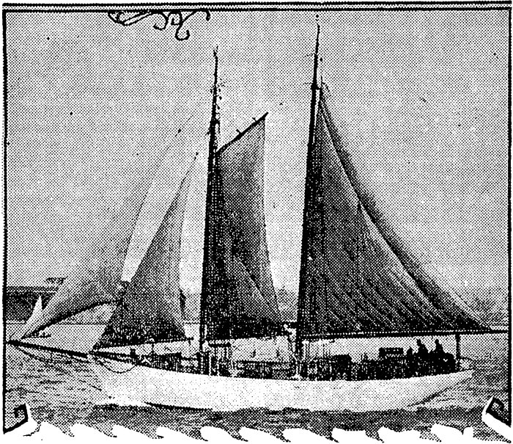
Valkyrie, an elegant gaff rigged schooner, built of quadruple planked Kauri, launched from Chas. Bailey yard in Auckland in 1928.
The graceful, historic racing yachts designed by the Logan and Bailey families in New Zealand are now amongst the finest examples of early New Zealand boat building. The kauri used in their construction is regarded as the finest boat building timber in the world for its beauty, ease of handling and its ability to last in water.
The yachts are highly prized and sought by collectors. They are legally protected in New Zealand and a prohibited export without Government authorization. And so is the Kauri wood that was used in their construction. They have been featured in Wooden Boat Magazine, which featured the boats and wood in a cover article, The Kauri Legacy.
Two Charitable Trusts in New Zealand - the Classic Yacht Charitable Trust of Auckland and the Wellington Classic Yacht Trust - have been formed to locate these boats, buy them and return them to New Zealand for restoration, where they are held by either proud owners, the Trusts or local Maritime Museums. There is also a Classic Yacht Association of New Zealand which promotes the ownership, preservation and restoration of Classic Yachts and Launches, and seeks to record the significant role that harbor and coastal sea craft have played in the development of New Zealand communities. It maintains a register of classic yachts and launches.
These early New Zealand vessels are prohibited exports under the New Zealand Protected Objects Act 1975. This prohibits the export of any antiquity - including vessels - more than 50 years old without special authorization.
Permission can be given if the Government authority administering the Act is satisfied that there are sufficient examples of that category in public ownership in New Zealand.
The export prohibition extends, as well, to the kauri wood. Felling kauri is prohibited, all the remaining forests are protected and now, mainly swamp wood is available. Any existing wood can only be exported for special approved projects - such as the restoration of Robert Erskine Childers’s 51’ Colin Archer designed ketch ASGARD nearing completion at the Museum of Ireland in Dublin.
VALKYRIE – now known as Valkyrien - is one of these treasured vessels, and, is among the largest examples of these special yachts.
Valkyrie at LOA 80ft and 60ft on deck is one of the few larger yachts from this period. Unlike many of the New Zealand classic yachts, which were built as coastal, river or harbor boats, or, to race - VALKYRIE was built to cruise the South Seas. Were Valkyrie in New Zealand, export permission would be unlikely. There are not many of these classic yachts as large and solid as Valkyrie.
Most of those being restored and featured are in a range up to 40 ft. The oldest classic yacht in New Zealand is the beloved JESSIE LOGAN – a 130 year-old gaff cutter that features a centerboard. She is just 28’ 6”
Possibly because Valkyrie was to tackle the Pacific Ocean, she was given an extra skin - quadruple kauri planking. This has given her a sturdy hull that has allowed her to withstand 84 years on the Pacific Ocean, including time as a seconded vessel used by the US Navy as a barge in the Second World War; a reconnaissance trip to Pitcairn with the CIA to observe the tests on the Mururoa Atoll; time dredging coral in Hawaii and, later, racing in San Francisco, before embarking on an epic sea journey from San Francisco to Panama – heading for the Panama Canal and Washington DC.
The hull even survived a month on a surf beach in the Bay of Panama, after being moored inshore on a high spring tide. Her hull - despite 84 years of hard labour - has kept its shape and line and merely needs a few planks, fresh caulking and paint for her to be as sound as she ever was. It is not hogged.
Her size and her planking make her a unique example of this era.
WAITANGI, launched in 1894 is the largest survivor of the Logan Brothers yachts. She has a waterline length of 38 ft and LOA of 74 ft. Neglected and in decline she was purchased and restored painstakingly by a syndicate of Melbourne businessmen and sailors, which conducted a carefully researched restoration. The work took eight years.
Her rigging, sail plan, hull and interior are exactly as built by Robert Logan – down to the smallest detail. She was re-launched in 1994 to celebrate her 100th birthday. In 2000, she was shipped to Auckland to compete in the Logan Classic Race. After her return to Melbourne, she was put up for international tender.
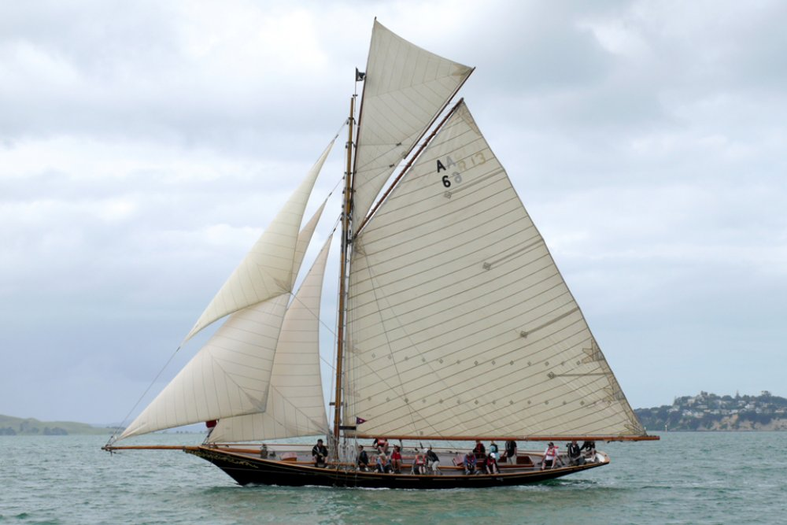
Waitangi – Logan Classic
The Classic Yacht Charitable Trust of Auckland was established in 2002 to ensure that the classic Logan yacht, WAITANGI remained in the Southern hemisphere. She was purchased to ensure that she stayed in Southern waters, after she was put up for international tender. She now sails permanently in New Zealand.
Much of the initiative for the Auckland Trust came from Auckland businessman John Street - the local Harken dealer – who has taken an active part in developing New Zealand’s yachting industry. He is now a Patron of the Trust and on the Board of Harken New Zealand. The Wellington Charitable Trust also acquires these vintage boats and undertakes restoration, but they work on a smaller budget and concentrate of smaller vessels associated with the Wellington region.
New Zealand enthusiasts are now putting much time and money to bring their wide range of boats back to original. In so doing they are preserving history and creating a fantastic museum quality collection of outstanding older vessels. The examples are many.
The Charitable Trust has a small fleet of Classics: THELMA, a Logan Classic built in 1897 is similar in size to VALKYRIE; FRANCES, another Logan classic built in 1906 has a LOA of 44 ft and is 38 ft on deck; GLORIANA the 24 ft yacht launched in 1892, which is credited for establishing the Logan boatbuilding fame due to its outstanding performance as a racing yacht; TE HAURAKI a 40 ft motor launch built for the Auckland Harbour Board in 1920.
Typical of workboats of the era, she is a beautiful launch and works for The Charitable Yacht Trust of Auckland as the fleet’s tender - capable of responding to emergencies when this special fleet of classics is on the water.
Check here for Sailing Videos.
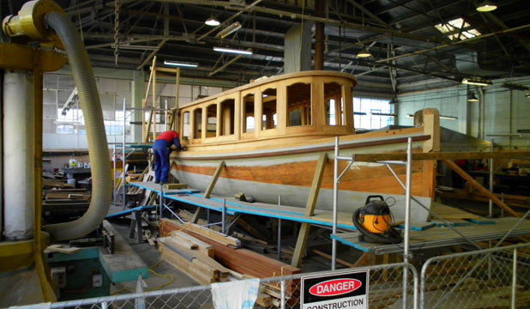
Beyond these Trusts, there is a national movement to preserve and use these old classics. One just returning to the water is Timaru’s first pilot boat - the ELSIE EVANS – from the Chas. Bailey yard. It has just undergone a $500,000 restoration and is to start a new life in the Dunedin Harbour as a harbour ferry and excursion boat. Another workboat saved from extinction is FERRO, built for the Ferro Cement Company of Australasia in 1905 by Logan Bros.
All the Classics from the Bailey and Logan boat-building yards have several things in common and the background of VALKYRIE conforms to this pattern. They all boast:
- Good tales of their early days with some of the more colorful characters in yachting
- A period of decline in which they were converted and neglected and then…
- Repaired with new super structures that changed their appearance and lines
- A few were taken over by the U S Navy during the Second World War

VALKYRIE’s GOOD TALES
VALKYRIE, launched in 1928 from the yard of Chas. Bailey, was built to cruise the Pacific. Her maiden voyage was to ‘film the unknown islands of the South Seas’.
‘Bound on a six thousand-mile voyage through the romantic islands of the South Seas … to plunge into the combers of the Pacific Ocean …. The cruise of the Valkyrie will be the most romantic,’ stated a glowing double column article in the ’Sun’ – a local newspaper.

The venture boasted the crème de la crème of movies and journalism and their names on the Yacht’s letterhead. Among them: Alexander Markey, a Hollywood film producer, who had come to New Zealand to direct Under The Southern Cross for Universal Studios. He had stayed on to film the Maoris and make his own movie Hei Tiki. It was now proposed to "film the unknown islands of the South Seas”

Thomas Stuart Gurr of the Asiatic and Consolidated Press, Sydney , Monte Blue a noted film star, a Stanley S. Schnitzler of the Scribe Manuscript Club, Hollywood and Professor H. C. Brown PhD of Stanford University were also in on the venture and were to meet the VALKYRIE on her arrival in Suva.

Not much is known of Ernest Gilling, but he was a character. He was among the crew aboard the Pleiades a steel sailing ship wrecked on the NZ Coast in 1899. In 1912, he made the first motor trip from Auckland to Wellington in a Model T Ford. The Wellington Evening Post published a small book about the venture and Gilling’s photo of the car on a rough road in the King Country is testimony to his quest for adventure.
Valkyrie offered passage and a share in the adventure to "a limited number of paying guests", who would "pay part expenses (not to exceed £3/10/- a week) for part or whole of a six months' cruise'. The offer tempted two men and three adventure-seeking women – young Doris Wilson – a budding writer and the Scott-Shaw’s - a mother and daughter, who left the farm for the lure of the islands. All were signed on as crew as the yacht was not permitted to carry passengers. She also carried Gilling as master; the crew was listed as Captain Townshend as mate, J. Martin as A.B,' and a mysterious “D. I. Gilling”, in charge of the culslne.

And so they sailed away, the "Valkyrie,'' with sail set, a perfect schooner-yacht from stem to stern, carrying a lighthearted "crew," bound nowhere in particular, but making for Suva as the first port of call.

But the "Valkyrie's'' romantic cruise'' was short-lived. VALKYRIE experienced one of the worst voyages ever. What should have been a week’s cruise extended to five, as the Pacific showed its force. For a time, all hope of the yacht ever being seen again was lost. And when, she at last reached her goal after, her passengers and crew wanted no more.

It was rated the worst trip from Auckland any craft had experienced. They were either becalmed or tossed all over the ocean, as they tried to hold course for Suva. Able-seaman Martin said that he had never experienced a trip so rough, and he spoke of the anxiety felt over the shortage of water when the craft had been out some weeks.

"We rationed the water, and there were three-parts of a kerosene tin a day for nine people to wash and cook with," he said.

There was no shortage of food, said Martin, but what was in the store was hardly fit to put before “paying guests" and women at that! Bully beef and biscuits abounded, together with some tins of preserved vegetables and fruit. It was edible sea-farers sustenance but inadequate for the landlubber Scott-Shaw’s, straight off the farm. They were practically in a state of collapse, he explained: They ate nothing, and there was no decent food to give them.

The passengers’ laments earned a full page article in the NZ TRUTH. VALKYRIE’s rendezvous with Alexander Markey came to naught. Perhaps, the vessel’s rough passage and delayed arrival soured matters, or, maybe, the desertion of paying passengers reduced finances. Either way, the filming adventure was over. It was time for a new adventure and Gilling set his eyes on a cruise for Norfolk Island. The advertisement appeared in the newspaper and Gilling was in trouble again!

VALKYRIE ran into a marital storm. His wife had found out that the boyish cook was in fact Gilling’s mistress. She got a court order on the VALKYRIE, as part of a demand for maintenance. The irrepressible NZ Truth reveled in the tale. However, Gilling satisfied the court and left again with his beloved schooner. It seems he then stayed in the Pacific Islands.

By November 10, 1935, Captain Gilling has been in Hawaii about 18 months. He was approached by Baron Corneille de Mey D’Alkemade with a request to charter VALKYRIE and sail through the Panama Canal and the Mediterranean loading up with war weapons on the way. The former follower of Lawrence of Arabia was planning a mission to save Ethiopia from Mussolini. Aboard would be some young American mercenaries. Gilling was not so sure. He mentioned Italian submarines. The good Baron scoffed: I will mount 4.7 naval guns fore and aft. He was ready for a naval battle!

Gilling also raised the question of difficulties passing Gibraltar and the Baron suggested the changing route around the Cape of Good Hope and setting up base on Mauritius. But Gilling’s sense of adventure was fading. He had been offered too many outlandish schemes – such as touring the Western Pacific filming hurricanes, typhoons and head hunters.

He doubted anyone knew what a typhoon was: It’s like driving a car at 100 mph without a windshield. The air is dark and filled with fine driving rain. Impossible conditions for photography!

VALKYRIE was sold in 1937 to a US citizen. The tales of Captain Ernest Gilling ended. VALKYRIE started life in America. Pearl Harbour was bombed December 7, 1941, America was at war and the VALKYRIE was seconded by the US Navy. She became a cargo barge under tow. After the war ended, she was a mast-less hull in Pearl Harbour. She was in decline.

But her life in America has just begun.

REBUILD in Hawaii

Journey to Mururoa

RACING SUCCESS

PEARL Foundation
Abandoned on surf beach
FUTRE
Insurance

